**ZERO 2 HERO logo information**

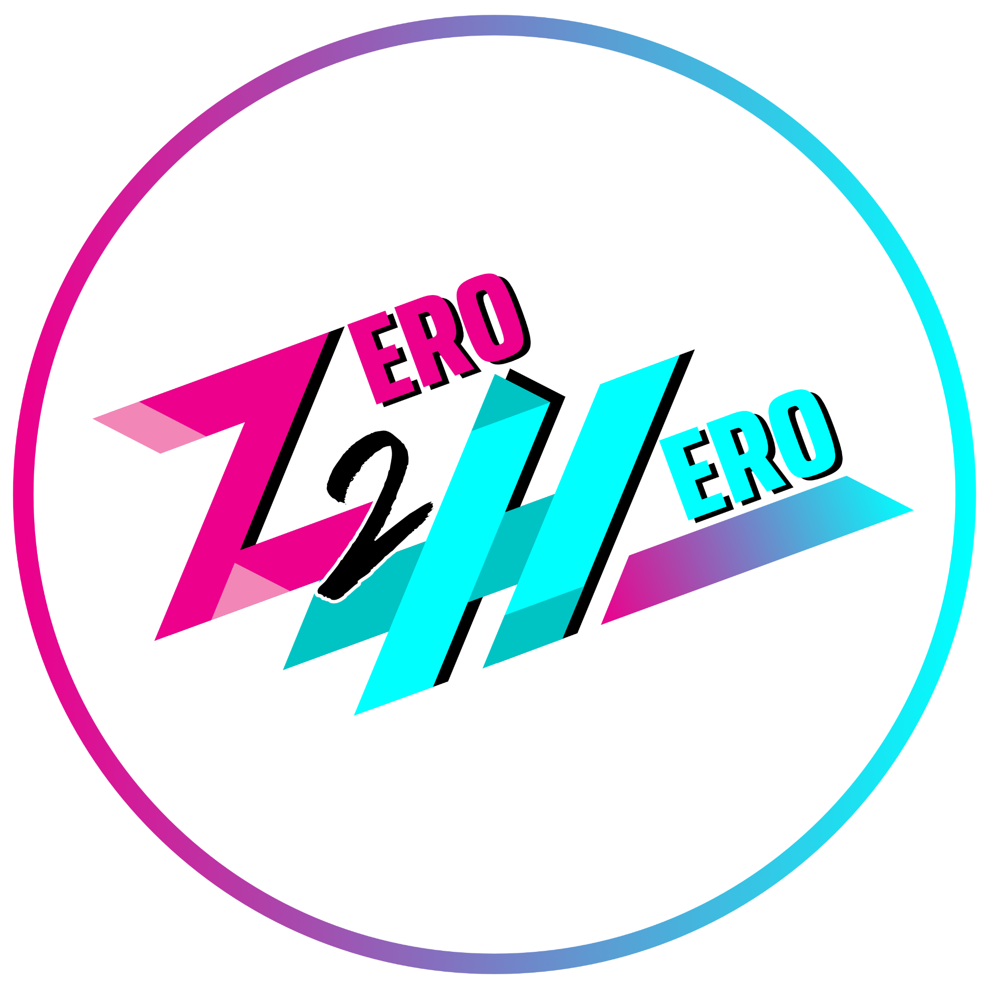

**FONTS**

“ERO” font: Saira Extra Condensed

“2” font: Have Heart One

Logo is “rotated” -20° from horizontal baseline

*Logo is a loose interpretation of a super hero with a billowing cape flying upwards*

**COLORS**

|  | **HEX VALUE** |  | **C** | **M** | **Y** | **K** |
| --- | --- | --- | --- | --- | --- | --- |
|  | EC008C |  | 0 | 99 | 1 | 0 |
|  | F287B6 |  | 0 | 60 | 0 | 0 |
|  | 00FFFF |  | 52 | 0 | 13 | 0 |
|  | 00C4C4 |  | 69 | 0 | 29 | 0 |

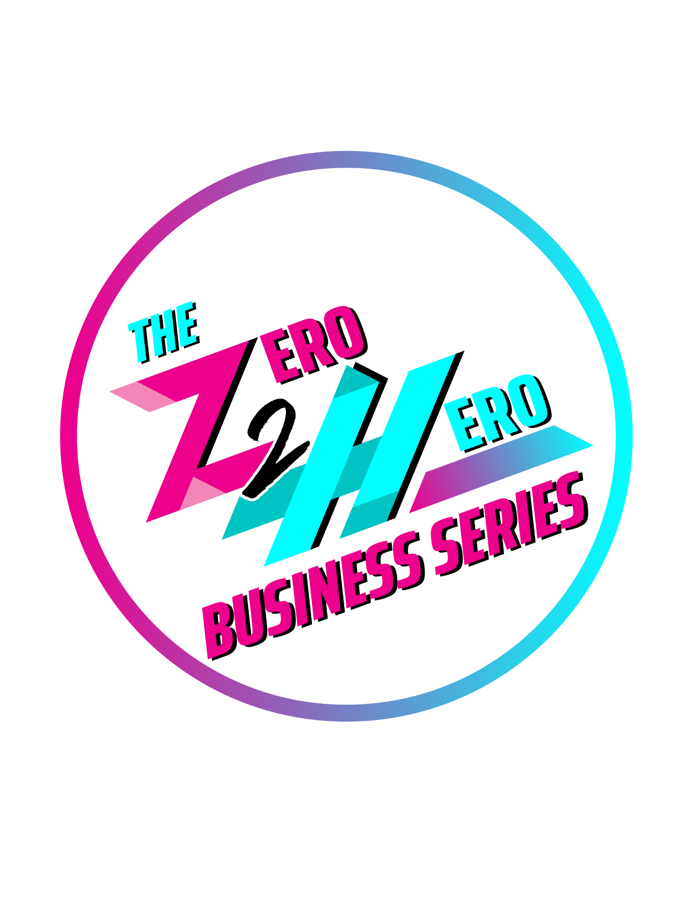

Supporting text should use one of the Saira family fonts… preferably the Saira Extra Condensed for main words

E.g. “Business Series” or “Training Event” etc.

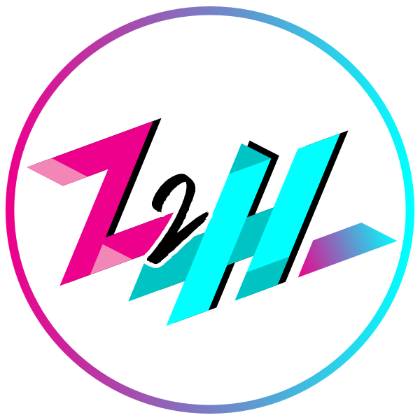

Small Usage logo “without the EROs”

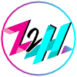

Favicon logo